Task 2
A. Create a career plan.
I want to become a bioinformatician. I plan to do this by first completing my undergraduate program in biochemistry and molecular biology which I have already done. My next step is to gain experience while studying a masters program in data science at WGU so I have combine the experience of biomedical research with the expertise of software skills and data analysis to have the full potential and the skills necessary to thrive in the biotechnology and biopharmaceutical industries.
1. Describe three different roles or careers in data analytics.
Data analysts collect, analyze, and interpret datasets, Business Intelligence Analyst helps makes decisions for a business, and Data Engineer maintain and design the databases used to carry data and ensuring accessibility.
a. Discuss the differences between roles or careers from part A1.
Business Intelligence Analyst
A Business Intelligence Analyst specializes in transforming raw data into actionable business insights. While they share similarities with Data Analysts, their work is specifically applied within a business context. BI Analysts primarily work with business intelligence tools such as Tableau to develop interactive dashboards that give stakeholders with real-time insights. BI analysts use SQL to query databases and structure data for reporting. In comparison to Data Analysts, BI Analysts are more concerned with business metrics and reporting rather than deep statistical analysis or predictive modeling.
Data Analyst
A Data Analyst focuses on collecting, cleaning, analyzing, and interpreting data to identify patterns and trends. Their primary role is to transform raw data into meaningful insights that can support decision-making. They use statistical techniques, data visualization tools, and programming languages to manipulate data and extract useful information. In contrast to BI Analysts, Data Analysts are not restricted to business-related applications. They work across a wide range of industries. Their work involves uncovering insights that help organizations optimize operations, predict future trends, or make data-driven decisions. However, Data Analysts typically focus on interpreting existing data rather than designing or maintaining the databases that store it (in contrast to DE).
Data Engineer
A Data Engineer is responsible for designing, building, and maintaining the infrastructure that allows data to be stored, processed, and accessed efficiently. In contrast to Data Analysts and BI Analysts, who focus on working with data to generate insights, Data Engineers ensure that the data itself is properly structured, reliable, and scalable. Their work involves things like developing data pipelines. Data Engineers collaborate with Data Analysts and BI Analysts by ensuring that they have access to clean, well-organized data for analysis and reporting. While Business Intelligence is strictly applied in a business setting, the Data engineers and likewise with Data Analysts work across various industries. Their role is fundamental in any data-driven field, as they lay the foundation that enables data analysis.
2. Describe how each role from part A1 supports the data analytics life cycle.
Data analyst supports the reporting and visualization part with interpreting the data sets, BI is with predictive modeling where they use this to help make decisions. Data engineer supports data acquisition because they build systems that collect, manage, and convert raw data into usable information that the data scientists can interpret.
B. Compare three different data analytics disciplines as described by ProjectPro.
Data scientist, Data engineer, and BI Analyst are all woven into the data analytics field. I noticed that they are very similar to each other. They are different in a way because DS analyzes the data and DE creates the structure for holding the databases that the DS will use. BI analyst goes into using the data to make a educated decision. The data engineer is different from DS and BI analyst because DE specifically designs the data infrastructure necessary for analysis, but it can be applied in various settings unlike with BI analyst which usually is applied in a specialized business setting. BI analysts are different and contrast from DS and DE because BI analysts is typically applied where they use the data they analyzed to make specialized decisions to influence a business whereas Data scientist primary analyze the data for learning about it and gaining future insight about it as well.
1. Identify three types of careers from the Bureau of Labor and Statistics government data in your career plan.
I had data analysts, machine learning engineer, and data engineer.
2. Identify your academic skills and needs for the careers considered in part B1.
For me my academic skills would be hard working. Resilient, good time management, being strategic and being a good listener. I would also want to be communicative and open-minded to other people as well as being creative.

C. Identify a potential career goal in your career plan based on your strengths and academic/MSDA track interests. My career goal is to become data scientist.
1. Reflect on your career strengths as identified in your personalized CliftonStrengths assessment results.
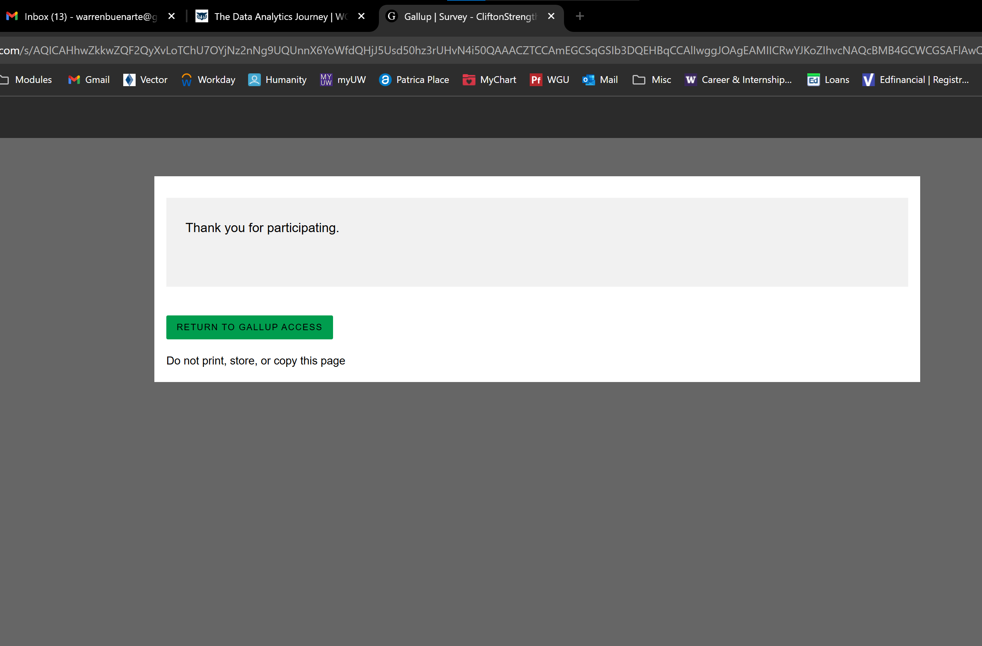
I noticed that my career strengths were being logical and concise. This would make sense for me because I always justify for decisions on using objective reasoning instead of subjective opinion. What I mean by this for example is that my decision making is based on empirical facts over opinions. When I was a undergraduate student, I used to work at Safeway and I had a disagreement with my coworker on how to restock items on the shelf and how it should be organized. Me and my co-worker got assigned to restock the liquor department but we were confused on how to put restock it. My way was to follow the barcode on the empty shelfs and align it with the exact number code on the product to the one on the shelf. My coworker wanted to restock the shelfs placing the products if identical overall (ex. If blue bud light bottles are needed to be stocked and we can see some on the shelf then that’s where we know where to stock it). I told him that is not completely accurate though because we have to get the product exactly right on the bar code on the shelf to the actual product by examining the number on it (bud light blue has code 3900 on the shelf, so the barcode on the product has to have that exact same number as well). This would be an example of how I was being logical and I was making a decision based on objectives facts, rather instead of subjective opinion. I was also being concise in this example because I explained to my co-worker what my reasoning was behind my decision in the succinct and coherent way.
D. Acknowledge sources, using in-text citations and references, for content that is quoted, paraphrased, or summarized.

E. Demonstrate professional communication in the content and presentation of your submission.

